# Question1 Implement non-relational data stores – D -

## Question1.1

You are a data engineer for your company. Your company wants to build an e-commerce site that allows vendors to sell their products online. Each vendor's product can have an arbitrary number of attributes. For example, Vendor A has a product named Bicycle Z that contains attributes Price, Description, Brand, PartNumber, and Size. Vendor B has the same product named Bicycle Z that contains attributes Price, Description, Weight, and Model. You want to implement a solution that does not restrict the product attributes that are used by each vendor. Your solution must allow you to use .NET to query product data.

You need to create the appropriate data store.  
  
Solution: You create a Cosmos DB account that uses the Table API.  
  
Does this solution meet the goal?

No

Yes

## Question1.2

You are a data engineer for your company. Your company wants to build an e-commerce site that allows vendors to sell their products online. Each vendor's product can have an arbitrary number of attributes. For example, Vendor A has a product named Bicycle Z that contains attributes Price, Description, Brand, PartNumber, and Size. Vendor B has the same product named Bicycle Z that contains attributes Price, Description, Weight, and Model. You want to implement a solution that does not restrict the product attributes that are used by each vendor. Your solution must allow you to use .NET to query product data.  
  
You need to create the appropriate data store.  
  
Solution: You create an Azure SQL Database account that uses a managed instance.  
  
Does this solution meet the goal?

No

Yes

## Question1.3

You are a data engineer for your company. Your company wants to build an e-commerce site that allows vendors to sell their products online. Each vendor's product can have an arbitrary number of attributes. For example, Vendor A has a product named Bicycle Z that contains attributes Price, Description, Brand, PartNumber, and Size. Vendor B has the same product named Bicycle Z that contains attributes Price, Description, Weight, and Model. You want to implement a solution that does not restrict the product attributes that are used by each vendor. Your solution must allow you to use .NET to query product data.  
  
You need to create the appropriate data store.  
  
Solution: You create a table storage account.  
  
Does this solution meet the goal?

No

Yes

## Question1.4

You are a data engineer for your company. Your company wants to build an e-commerce site that allows vendors to sell their products online. Each vendor's product can have an arbitrary number of attributes. For example, Vendor A has a product named Bicycle Z that contains attributes Price, Description, Brand, PartNumber, and Size. Vendor B has the same product named Bicycle Z that contains attributes Price, Description, Weight, and Model. You want to implement a solution that does not restrict the product attributes that are used by each vendor. Your solution must allow you to use .NET to query product data.  
  
You need to create the appropriate data store.  
  
Solution: You create a Cosmos DB account that uses the SQL API.  
  
Does this solution meet the goal?

No

Yes

# Question5 Implement non-relational data stores

Case Study

Complete the Case Study

* Overview

Company1 is a food delivery company with a global presence. Company1 data solutions use the following Azure data products:

* Azure Blob Storage to store order tracking status
* Azure Cosmos DB to store orders, restaurant (menu, address, contact info) and customer data
* Azure SQL Database elastic pool used by the company’s internal systems

You need to support plans to release this software in a new Azure region.

* Requirements
* The platform must be resilient in case of an outage impacting one Azure availability zone.
* You need to provide a mobile application secure access to the orders database that is hosted in Azure Cosmos DB.
* The mobile application needs to perform read and write queries directly to the orders database.
* The internal systems use 15 separate databases configured in an elastic pool.
* The internal system databases must be readable in case of availability zone outage.
* In this new region deployment, you need to provide an external partner of Company1 direct read access to the tracking order history that is stored in blob storage.
* Access to Company1 by the external partner should be limited and should automatically expire after two months.
* Orders Database

During the first marketing campaign of the previous regional launch, the database was the cause of a bottleneck while reading the orders collection. The Request Units (RU) database throughput needed to be increased in other to eliminate the bottleneck. Collections different from orders throughput did not change during the marketing campaign.

* Internal  
  system databases

You need to implement a daily administrative task on all databases. This administrative task is a script written in PowerShell.

## Question 5.1

You need to implement replication so that the internal system databases meet the requirements.   
  
Which two actions should you perform? Each correct answer presents part of the solution.

Configure SQL Data Sync for each database.

Create an Azure SQL Server elastic pool in another region.

Enable geo-replication for each database.

Create a Sync Group in elastic pool.

## Question 5.2-

you need to implement the redundancy strategy for order tracking status storage to meet the requirements. Costs need to be kept to a minimum.   
  
Which data redundancy strategy and storage account type should you use? To answer, select the appropriate options from the drop-down menus.

You have been given the task to implement the redundancy strategy for order tracking status storage to meet the appropriate requirements. The costs should have to be kept as minimum as possible.

What data redundancy strategy and storage account type should you be using? Select the relevant options to answer the question.

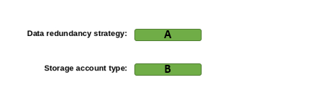

A)

1. Geo Redundant Storage (GRS)
2. Local Redundant Storage (LRS)
3. Zone Redundant Storage (ZRS)

B)

1. Block blob storage accounts
2. General-purpose v2

## Question 5.3-

You need to implement daily administrative tasks for the internal system databases. You need to minimize administrative efforts.   
  
Which solution should you use?

SQL Server Agent

Azure Alerts action group

Elastic Database Jobs

Azure Data Factory

## Question 5.4-

You need to create the necessary credentials for the mobile client application to connect with Azure Cosmos DB.   
  
Which credential key and permission should you use to to meet security requirements? To answer, select the appropriate options from the drop-down menus.

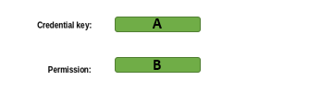

A)

1. Azure Active Directory (Azure AD) user
2. Master Key
3. Resource Toke

B)

1. All
2. Cosmos DB Operator role
3. Read

## Question 5.5-

You need to grant the external partner of Company1 access to the blob containers that store the order tracking status.    
  
Which authorization method should you use to meet security requirements?

Anonymous public read access

Shared Key authorization

Shared access signatures (SAS)

Azure Active Directory (Azure AD) role-based access control (RBAC)

# Question48 Implement non-relational data stores – D -

You have a globally distributed application with millions of documents stored in Cosmos DB.  
  
Your application is spread across five Azure regions and stores data as documents. An example is shown in the exhibit. The region field stores the original creation region. The sensorId is a unique field that does not repeat across the database.  
  
The application performs thousands of write and read operations per second, resulting in high throughput. Queries originated from the application usually filter the results by region and sensorId.  
  
You need to choose a proper partition key for Cosmos DB to meet the requirements.  
  
What partition key should you use?

Choose the correct answer

timestamp with random suffix

region

region with pre-calculated suffix based on sensorId

sensorId

# Question49 Implement non-relational data stores

You are developing an application that queries data from Azure Cosmos DB.  
  
The application will be hosted in multiple Azure App Services that are distributed across multiple regions. Data stored in Cosmos DB is updated frequently using a replica to write and read data in the same region.  
  
You need to ensure that read operations will return the most recent committed version of data. The application will consume Cosmos DB with the SQL API.  
  
The Cosmos DB account should be named GlobalDatabase in a resource group named MotorsWorldwide.  
  
You need to complete the Azure Command Line Interface (CLI) command to provision Azure Cosmos DB according to the requirements.  
  
How should you complete the code? To answer, select the appropriate options from the drop-down menus.

Choose the correct options

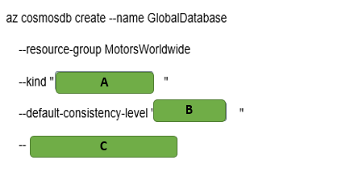

A)

1. GlobalDocumentDB
2. MongoDB
3. Parse

B)

1. Eventual
2. Session
3. Strong

C)

1. Enabable-automatic-failover
2. Enable-multiple-write-location
3. Enable-virtual-network

# Question82 Implement non-relational data stores - D

You are implementing a data engineering solution for your company. You plan to use Azure table storage to store receipts. Each receipt contains a date, a category, and a unique number. Over 50 percent of the receipts have the same category. These are the 10 most popular categories. Approximately five percent of the receipts have the same date.  
  
You need to define the row key and the partition key scheme.  
  
For each of the following statements, select Yes if you should perform the task. Otherwise, select No.

|  |  |  |
| --- | --- | --- |
| **Statement** | **Yes** | **No** |
| Specify the date as a partition key. |  |  |
| Specify the category as a partition key. |  |  |
| Specify the unique number as the row key. |  |  |

# Question83-

You work for a call center company that uses Azure SQL Database. The database stores customer credit card numbers in a table named PaymentInfo. Telemarketing attendants will consult this table to help with customer payment support.  
  
You need to implement dynamic data masking (DDM) in the PaymentInfo table to mask credit card numbers for telemarketing attendants. Only the two first digits and the last four digits should be visible.  
  
How should you complete the T-SQL query? To answer, select the appropriate options from the drop-down menus.

Choose the correct options

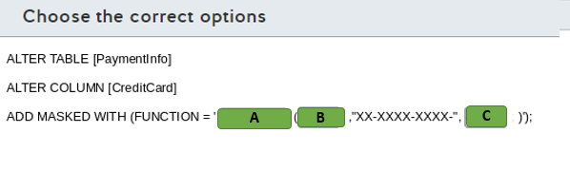

A)

1. Default
2. Partial
3. random

B)

1. 0
2. 2
3. 4

C)

1. 0
2. 2
3. 4

# Question84-

You are a data engineer. You manage three SQL Server databases in Azure. The databases must meet the following security requirements:  
  
Database 1 - Only specific columns in the 10 tables must be encrypted.  
Database 2 - All data in the entire database must be encrypted at rest.  
Database 3 - Data must be encrypted while in transit between the client application and Azure.  
  
You need to determine which encryption technology to use for each database.  
  
Which encryption technology should you use for each database? To answer, choose the correct encryption technology from the drop-down menus.

Choose the correct options

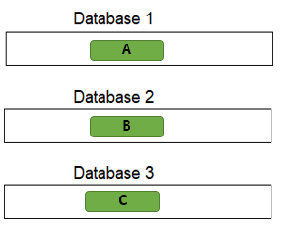

A)

1. Always Encrypted
2. Transparent Data Encryption

B)

1. Always Encrypted
2. Transparent Data Encryption

C)

1. Always Encrypted
2. Transparent Data Encryption

# Question85-

You manage an Azure SQL database for a financial application.   
  
You need to configure a dynamic data mask to completely mask the data of a specific varchar field.   
  
Which masking function should you use?

Choose the correct answer

Email

Default

Partial

Random

# Question86-

You manage an Azure SQL Database for a mission-critical application named ElectronicsProduction. The database stores personal information about your users.  
  
You need to implement Transparent Data Encryption (TDE) with a customer-managed encryption key in this database. You assign an Azure Active Directory (AD) identity in Azure SQL Database.  
  
Which five actions should you perform in sequence? To answer, move the appropriate actions from the list of possible actions to the answer area and arrange them in the correct order.

Create a list in the correct order

Possible actions

Actions in order

* Create a master key in the master database.
* Create a server certificate using the master key.
* Create a database encryption key from the certificate in ElectronicsProduction.
* Create an Azure Key Vault and generate a new key.
* Grant Key Vault permissions to the Azure SQL Database server.
* Add the Key Vault key to the Azure SQL Database server.
* Set the TDE Protector to use the Key Vault key.
* Enable encryption in the ElectronicsProduction database.

# Question87 Implement non-relational data stores - D

You are a data engineer for your company. You use the following Azure CLI commands to create an Azure Cosmos DB account. You plan to use this account to store sales data.  
  
az cosmosdb create --resource-group 'sales-rg' --name 'sales' --kind GlobalDocumentDB \  
--locations regionName="South Central US" failoverPriority=0 \  
--locations regionName="North Central US" failoverPriority=1 \  
--default-consistency-level "Strong" --enable-multiple-write-locations true  
  
You need to answer questions regarding sales data queries and updates.  
  
For each of the following statements, select Yes if the statement is true. Otherwise, select No.

|  |  |  |
| --- | --- | --- |
| **Statement** | **Yes** | **No** |
| You can query data by using Gremlin API. |  |  |
| A client can see partial writes of a sales data record by default. |  |  |
| A client can set the consistency level to Eventual Consistency at connection time. |  |  |
| A client can set a different consistency level during each request to sales data. |  |  |

# Question92 Implement non-relational data stores - D

You are a data engineer for an exam development company. You create an Azure Cosmos DB account that uses the session consistency level. You create a database and collection that allows exam developers to create and store exam content.  
  
Developer A and Developer B reside in Virginia, United States. Developer C resides in Madrid, Spain. At 12:00, the question entity has its difficulty attribute set to Hard. All three developers read the value Hard. Developer A then changes the difficulty attribute to Medium. All three developers then immediately read the entity before replication occurs.  
  
You need to answer questions regarding the reads.  
  
For each of the following statements, select Yes if the statement is true. Otherwise, select No.

|  |  |  |
| --- | --- | --- |
| **Statement** | **Yes** | **No** |
| Developer A will read Medium. |  |  |
| Developer B will read Medium. |  |  |
| Developer C will read Hard. |  |  |

# Question105 Implement non-relational data stores -D

Users named Alan and Kerry are members of the Marketing Azure Active Directory (Azure AD) security group, set as a primary one for their Azure AD accounts. Kerry and another user named David are members of the Finance security group, set as a primary for David’s account.  
  
You set up a new directory in Azure Data Lake Storage and set the owning group to Finance. Kerry creates a new text file in that directory as an extract from the Sales database. Your audit report indicates that the access control list (ACL) for that file is set to 640 in the POSIX format.  
  
You need to determine what access permissions Alan, Kerry, and David all have to the newly uploaded text file.  
  
What permissions do they have? To answer, drag the appropriate permission option to each user’s ACL column. A permission option may be used once, more than once, or not at all.

Drag and drop the answers

https://pts.measureup.com/web/instances/MUP/assets/images/DP-200/DP-200_63632/ltMS_DP-200_SelectPlace_1(9).jpeg

https://pts.measureup.com/web/instances/MUP/assets/images/DP-200/DP-200_63632/ltMS_DP-200_SelectPlace_1(11).jpeg

https://pts.measureup.com/web/instances/MUP/assets/images/DP-200/DP-200_63632/ltMS_DP-200_SelectPlace_1(13).jpeg

https://pts.measureup.com/web/instances/MUP/assets/images/DP-200/DP-200_63632/ltMS_DP-200_SelectPlace_1(9).jpeg

https://pts.measureup.com/web/instances/MUP/assets/images/DP-200/DP-200_63632/ltMS_DP-200_SelectPlace_1(11).jpeg

https://pts.measureup.com/web/instances/MUP/assets/images/DP-200/DP-200_63632/ltMS_DP-200_SelectPlace_1(13).jpeg

https://pts.measureup.com/web/instances/MUP/assets/images/DP-200/DP-200_63632/ltMS_DP-200_SelectPlace_1(8).jpeg

https://pts.measureup.com/web/instances/MUP/assets/images/DP-200/DP-200_63632/ltMS_DP-200_SelectPlace_1(10).jpeg

https://pts.measureup.com/web/instances/MUP/assets/images/DP-200/DP-200_63632/ltMS_DP-200_SelectPlace_1(12).jpeg

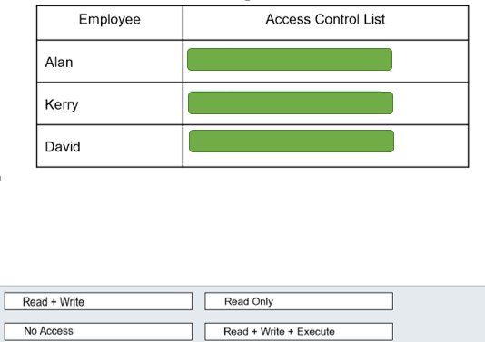

# Question106 Implement non-relational data stores - D

You are a data engineer for an insurance company. You create an Azure Cosmos DB account that uses the strong consistency level. You create a database and a collection that allows personnel to manage insurance claims. Employee A and Employee B reside in Virginia, United States. Employee C resides in Madrid, Spain. At 12:00, a claim entity has its status attribute set to Pending. Employee A then changes the status attribute to Closed. All three employees then immediately read the entity before it is committed and before synchronization occurs.  
  
You need to answer questions regarding the reads.  
  
To answer, select Yes if the statement is true. Otherwise, select No.

|  |  |  |
| --- | --- | --- |
| **Statement** | **Yes** | **No** |
| Employee A reads Closed. |  |  |
| Employee B reads Pending. |  |  |
| Employee C reads Pending. |  |  |

# Question107 Implement non-relational data stores - D

You are a data engineer for your company. You are creating an Azure Cosmos DB account to store an existing product catalog. The existing product catalog currently exists as a single Oracle database table. Approximately 20 percent of the columns in the table are empty.  
  
Each product type can have different attribute names and a different attribute count. You must be able to search the catalog by product id and category. You must be able to search for products in the Clothing category by size. You must be able to search for products in the Laptop category by CPU speed. You also must be able to query data by using the following syntax from a web application:  
  
SELECT p.productName FROM Products p  
  
You need to choose the most appropriate API.  
  
Which API should you choose?

SELECT p.productName FROM Products p  
  
You need to choose the most appropriate API.  
  
Which API should you choose?

Choose the correct answer

MongoDB API

Table API

Core SQL API

Gremlin API

# Question110 Implement non-relational data stores - D

You are building a new CRM solution with Azure Cosmos DB as a backend. You plan to use an Apache TinkerPop compatible framework.  
  
Your consumers, promotions, and products will become vertices in your CRM’s graph structure, while the references to the events your consumers attended and the specific products they bought will form the graph’s edges.  
  
You need to choose the right API in Azure Cosmos DB to build the graph database algorithms.  
  
What should you do?

Choose the correct answer

Use Table API.

Use MongoDB API.

Use SQL API.

Use Cassandra API.

Use Gremlin API.

# Question113 Implement non-relational data stores - D

Your team is planning to use Azure Cosmos DB as the data store for a multi-region application.   
  
You need to choose a default consistency model with the lowest latency between the application and Cosmos DB.   
  
Which consistency model should you use?

Choose the correct answer

Eventual

Consistent Prefix

Session

Strong

Bounded Staleness

# Question123 Implement non-relational data stores - D

Your team is developing an application with Azure Cosmos DB as the data solution. The application will use the MongoDB API for a document-based database to store items.   
  
You need to provision Cosmos DB with the correct container and item types.   
  
Which container and item types should you use? Each correct answer presents part of the solution.

Drag and drop the answers

https://pts.measureup.com/web/instances/MUP/assets/images/DP-200/DP-200_65235/gsDP-200_003d.gif

https://pts.measureup.com/web/instances/MUP/assets/images/DP-200/DP-200_65235/gsDP-200_003b.gif

https://pts.measureup.com/web/instances/MUP/assets/images/DP-200/DP-200_65235/gsDP-200_003d.gif

https://pts.measureup.com/web/instances/MUP/assets/images/DP-200/DP-200_65235/gsDP-200_003b.gif

https://pts.measureup.com/web/instances/MUP/assets/images/DP-200/DP-200_65235/gsDP-200_003e.gif

https://pts.measureup.com/web/instances/MUP/assets/images/DP-200/DP-200_65235/gsDP-200_003c.gif

https://pts.measureup.com/web/instances/MUP/assets/images/DP-200/DP-200_65235/gsDP-200_003a.gif

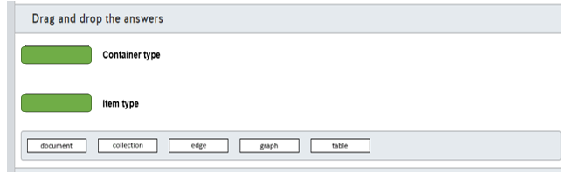

# Question150 Implement non-relational data stores - D

You are a data engineer for a practice test provider. You plan to use an Azure Cosmos DB to store exam content. You must be able to retrieve exam content by using a query similar to the following:  
  
SELECT * FROM Exams e WHERE e.number = "DP-200"  
  
You need to generate the Cosmos DB account and database.  
  
How should you complete the Azure CLI commands? To answer, select the appropriate options from the drop-down menus.

Choose the correct options

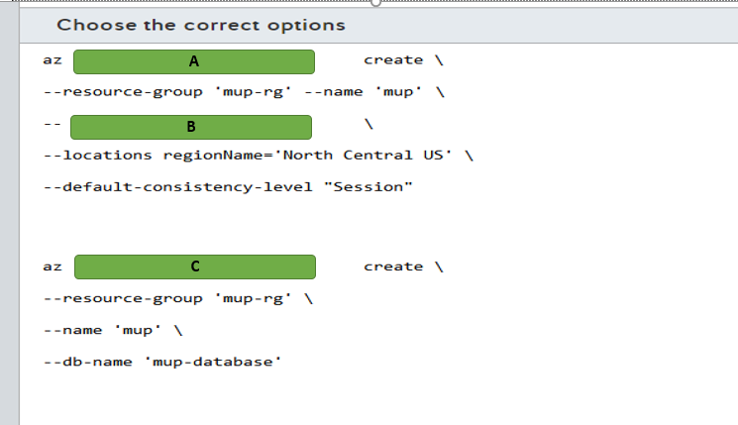

A)

1. Cosmodb
2. Cosmodb collection
3. Cosmodb database

B)

1. Capabilities EnableCassandra
2. Capabilities EnableGremlin
3. Capabilities EnablesTable
4. Kind GlobalDocumentDB
5. Kind MongoDB

C)

1. Cosmodb
2. Cosmodb collection
3. Cosmodb database